IDPE 2023 Celebration of Giving social media toolkit

*IDPE's Celebration of Giving is an opportunity for all schools (both independent and state) to come together and celebrate the generosity of their communities and the impact of schools' fundraising and engagement on the lives of young people.*

*From Monday 13 - Friday 17 November 2023, we encourage you to share your stories on social media to celebrate giving within your school community. We have put together this toolkit to make it as easy as possible to participate, but feel free to adapt these ideas and create your own.*

***Please tag us and our Headline sponsor, Hubbub, in your posts:***

* ***X (Formerly known as Twitter)***
  + ***@IDPE_Europe***
  + ***@hubbubnet***
* ***LinkedIn***
  + ***The Institute of Development Professionals in Education (IDPE)***
  + ***hubbub fundraising***

***Hashtag: #IDPEGivingWeek***

We would love you to share your success stories and case studies. For example, you could write about:

* A recent capital campaign
* Your school’s bursary campaign
* A careers event
* A giving day
* Your school’s philanthropic history
* Thanking your volunteers and encouraging others in your school community
* And anything else that you’re proud of

Some inspiration from last year:

 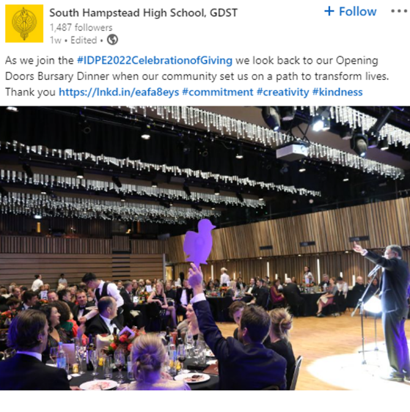

 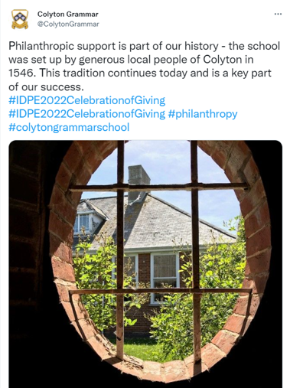

## Visuals to use

### Celebration of Giving logo

### Social media images

