IDPE 2025 Celebration of Giving social media toolkit

IDPE's Celebration of Giving is an opportunity for all schools (both independent and state) to come together and celebrate the generosity of their communities and the impact of schools' fundraising and engagement on the lives of young people.

From Monday 17 - Friday 21 November 2025, we encourage you to share your stories on social media to celebrate giving within your school community. We have put together this toolkit to make it as easy as possible to participate, but feel free to adapt these ideas and create your own.

Please tag us in your posts:
- Twitter/X: @IDPE_Europe
- LinkedIn: The Institute of Development Professionals in Education (IDPE)

Hashtag: #IDPEGivingWeek
Webpage: https://idpe.org.uk/#idpecelebrationofgiving

We would love you to share your success stories and case studies. For example, you could write about:
- A recent capital campaign
- Your school’s bursary campaign
- A careers event
- A giving day
- Your school’s philanthropic history
- Thanking your volunteers and encouraging others in your school community to volunteers their time
- And anything else that you’re proud of

Visuals to use

Celebration of Giving logo
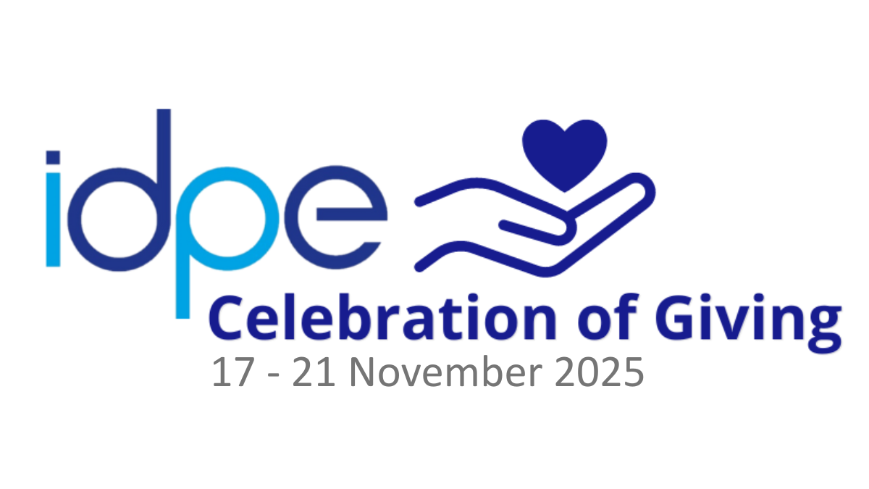

Social media images

